

**Capstone Project Report**

**Report 4 – Software Design Document**

– HoChiMinh, January 2025 –

Contents

I. Record of Changes 2

II. Software Design Document 3

1. System Design 3

1.1 System Architecture 3

1.2 Package Diagram 7

2. Database Design 10

3. Detailed Design 16

3.1 Manage Pricing 16

3.2 Manage Booking 18

3.3 Manage Trip 24

# I. Record of Changes

|  |  |  |  |
| --- | --- | --- | --- |
| Date | A*  M, D | In charge | Change Description |
|  |  |  |  |
|  |  |  |  |
|  |  |  |  |
|  |  |  |  |
|  |  |  |  |
|  |  |  |  |
|  |  |  |  |
|  |  |  |  |
|  |  |  |  |
|  |  |  |  |
|  |  |  |  |
|  |  |  |  |
|  |  |  |  |

*A - Added M - Modified D - Deleted

# II. Software Design Document

## 1. System Design

### 1.1 System Architecture

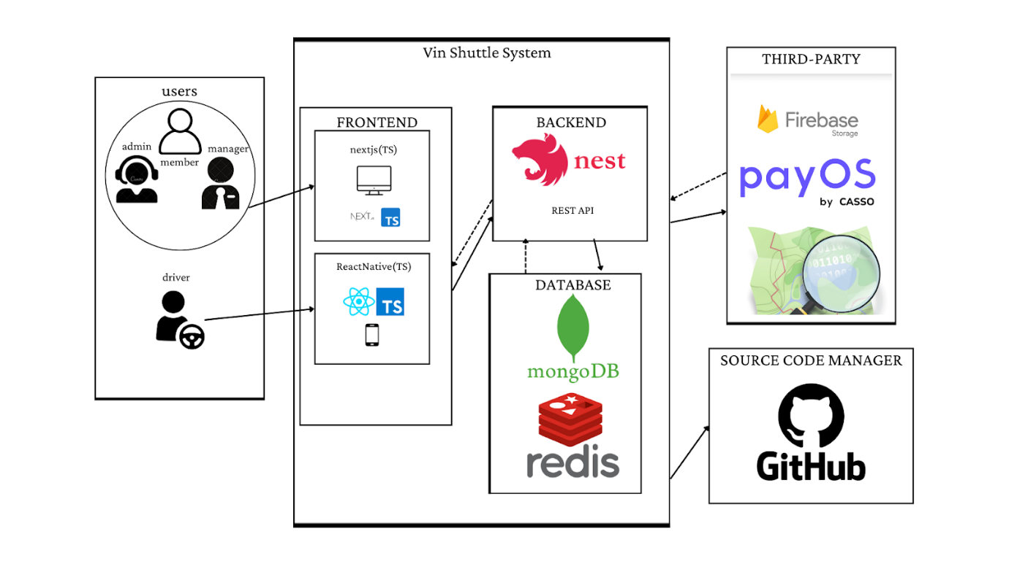

#### 1.1.1. API architecture diagram

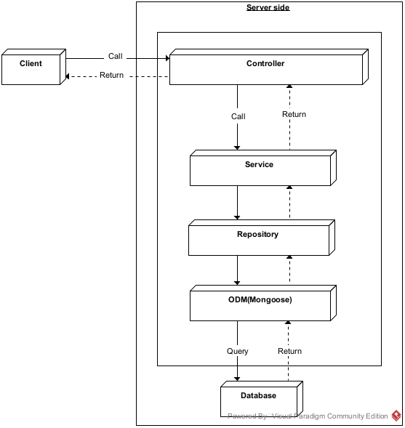

#### 1.1.2. Mobile Application architecture diagram

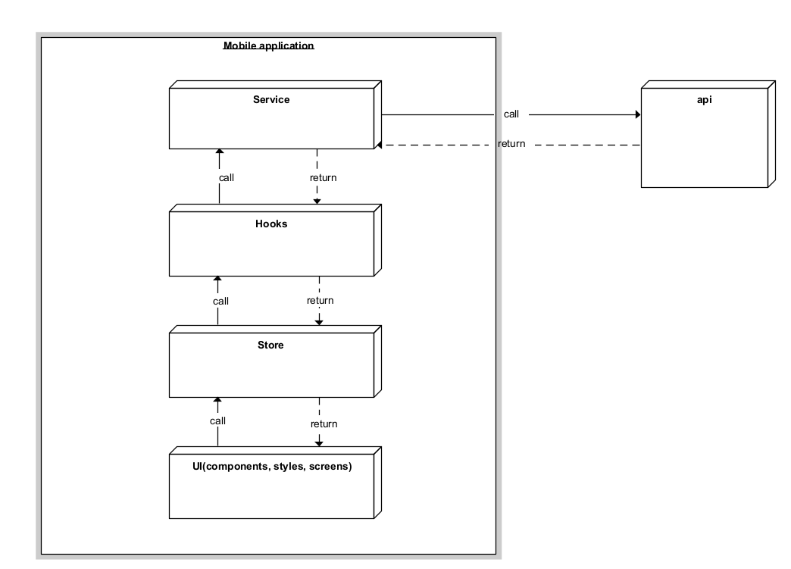

#### 1.1.3. Web Application architecture diagram

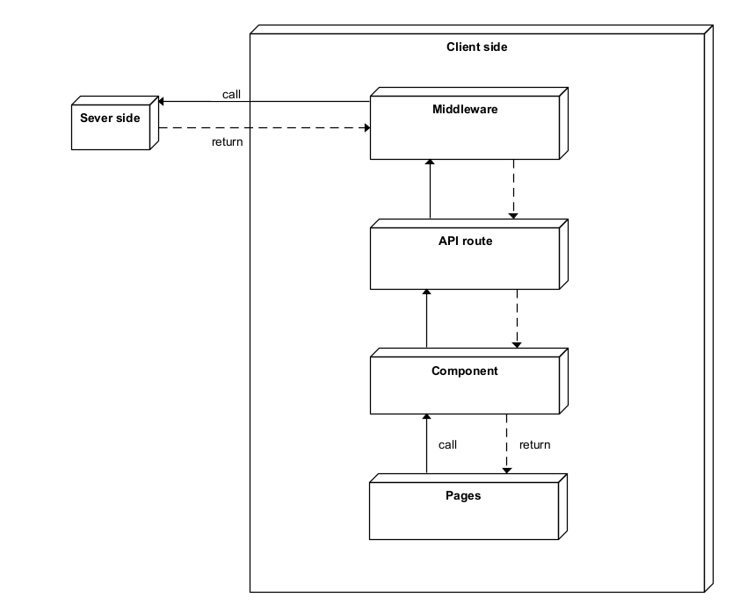

### 1.2 Package Diagram

#### 1.2.1 Web API package diagram

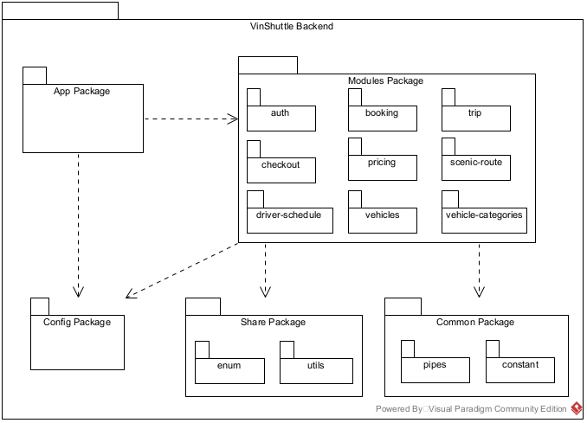

#### 1.2.2 Web application package diagram

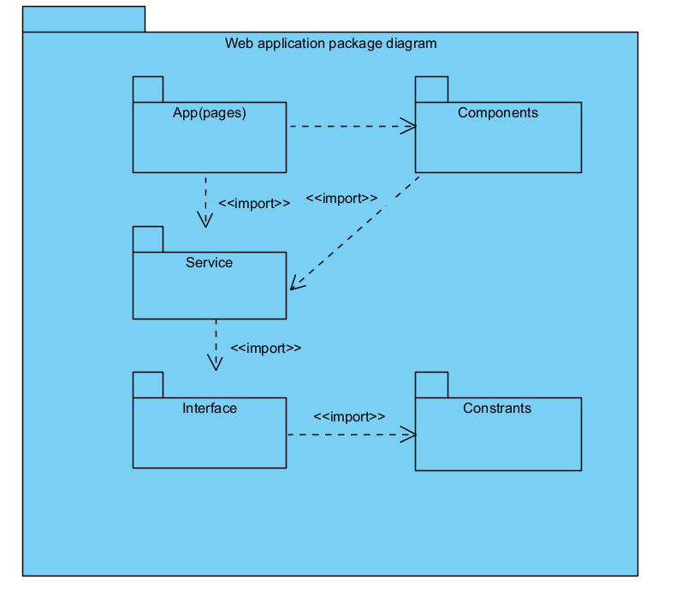

#### 1.2.3. Mobile application package diagram

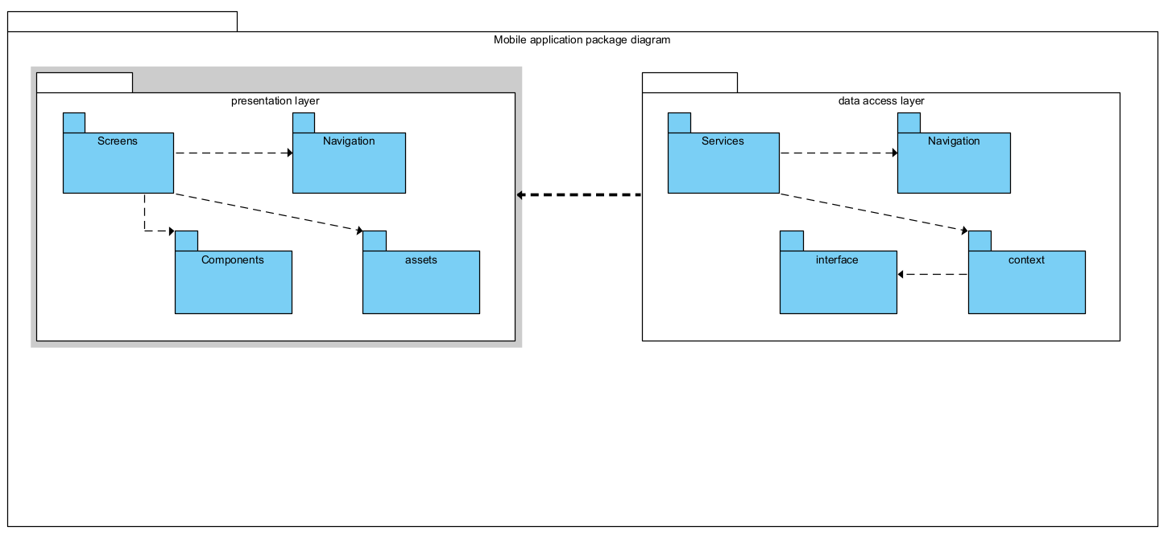

***Package Descriptions***

|  |  |  |
| --- | --- | --- |
| ***No*** | ***Package*** | ***Description*** |
| 01 | Web API package diagram | This diagram provides an overview of the package organisation for a Web API-based backend service. |
| 02 | Web application package diagram | This diagram illustrates the package structure for a web application that includes both backend and frontend components. |
| 03 | Mobile application package diagram | This diagram represents the package structure of a mobile application, organising UI, data, and service layers to support seamless user experiences and efficient data handling. |

## 2. Database Design

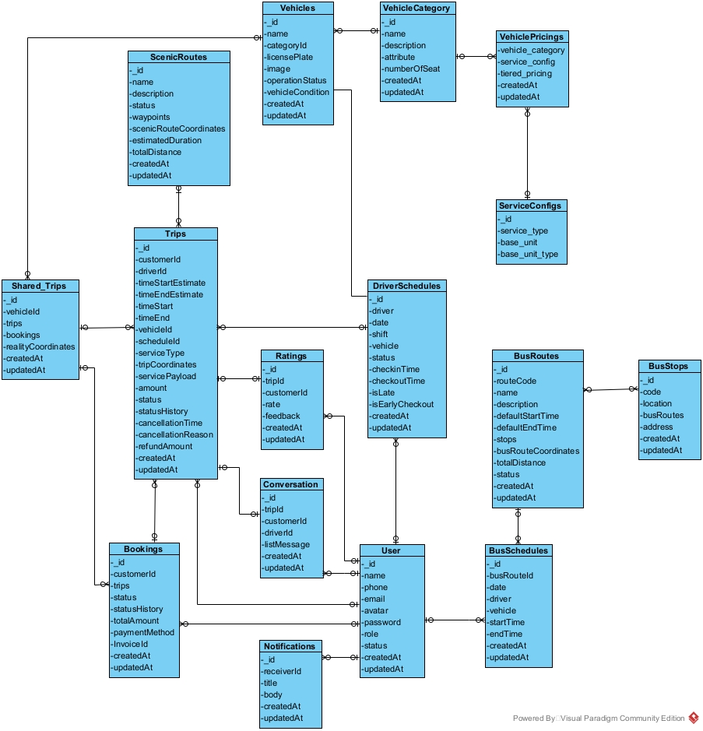

***Table Descriptions***

|  |  |  |
| --- | --- | --- |
| **No** | **Table** | **Description** |
| *01* | *ScenicRoutes* | *Describe ScenicRoutes in the system* |
| *02* | *Vehicles* | *Describe Vehicles in the system* |
| *03* | *VehicleCategory* | *Describe VehicleCategory in the system* |
| *04* | *VehiclePricings* | *Describe VehiclePricings in the system* |
| *05* | *Shared_Trips* | *Describe Shared_Trips in the system* |
| *06* | *Trips* | *Describe Trips in the system* |
| *07* | *Ratings* | *Describe Ratings in the system* |
| *08* | *DriverSchedules* | *Describe DriverSchedules in the system* |
| *09* | *ServiceConfigs* | *Describe ServiceConfigs in the system* |
| *10* | *Bookings* | *Describe Bookings in the system* |
| *11* | *Conversation* | *Describe Conversation in the system* |
| *12* | *users* | *Describe users in the system* |
| *13* | *BusRoutes* | *Describe BusRoutes in the system* |
| *14* | *BusStops* | *Describe BusStops in the system* |
| *15* | *Notifications* | *Describe Notifications in the system* |
| *16* | *BusSchedules* | *Describe BusSchedules in the system* |

**Attribute Data Dictionary**

|  |  |  |  |  |
| --- | --- | --- | --- | --- |
| Entity name | Attribute | Description | Domain | Null |
| *ScenicRoutes* | _id | Unique identification system *ScenicRoutes* | ObjectId | NO |
| name | *ScenicRoutes name* | String | NO |
| description | *ScenicRoutes description* | String |  |
| status | *ScenicRoutes status* | String |  |
| waypoints | waypoints of routes | Array |  |
| scenicRouteCoordinates | scenicRouteCoordinates | Array |  |
| estimatedDuration | Estimated time to complete the route | Double |  |
| totalDistance | total Distance of route | Double |  |
| createdAt | create time | Date |  |
| updatedAt | update time | Date |  |
| *Vehicles* | _id | Unique identification system *Vehicles* | ObjectId |  |
| name | *Vehicles name* | string |  |
| categoryId | Vehicle category identifier, associated with the vehicle category | ObjectId |  |
| licensePlate | license plate *Vehicles* | string |  |
| isActive | Vehicle operating status | boolean |  |
| status | Condition of the vehicle | string |  |
| createdAt | create time | date |  |
| updatedAt | update time | date |  |
| *VehicleCategory* | _id | A unique identifier for each vehicle category. | ObjectId |  |
| name | The name of the vehicle category | string |  |
| description | A brief description of the vehicle category, explaining its characteristics or usage. | string |  |
| numberOfSeat | The standard number of seats available in vehicles belonging to this category | int |  |
| *VehiclePricings* | _id | Unique identifier for the vehicle pricing entry | ObjectId |  |
| vehicle_category | Reference to the vehicle category being priced | ObjectId |  |
| service_config | Configuration details of the service pricing | ObjectId |  |
| tiered_pricing | Pricing structure based on different tiers | Array |  |
| createdAt | Timestamp when the pricing record was created | Date |  |
| updatedAt | Timestamp when the pricing record was last updated | Date |  |
| *Shared_Trips* |  |  |  |  |
|  |  |  |  |
|  |  |  |  |
|  |  |  |  |
|  |  |  |  |
|  |  |  |  |
|  |  |  |  |
| *Trips* | _id | Unique identifier for the trip |  |  |
|  | customerId | Reference to the customer who booked the trip |  |  |
|  | driverId | Reference to the driver assigned to the trip |  |  |
|  | timeStart | Actual start time of the trip |  |  |
|  | timeEnd | Actual end time of the trip |  |  |
|  | timeStartEstimate | Estimated start time of the trip |  |  |
|  | timeEndEstimate | Estimated end time of the trip |  |  |
|  | vehicleId | Reference to the vehicle used for the trip |  |  |
|  | scheduleId |  |  |  |
|  | serviceType |  |  |  |
|  | servicePayload |  |  |  |
|  | amount |  |  |  |
|  | status |  |  |  |
|  | tripCoordinates |  |  |  |
|  | statusHistory |  |  |  |
|  | createdAt |  |  |  |
|  | updatedAt |  |  |  |

## 3. Detailed Design

### 3.1 Manage Pricing

#### 3.1.1 Pricing Class Diagram

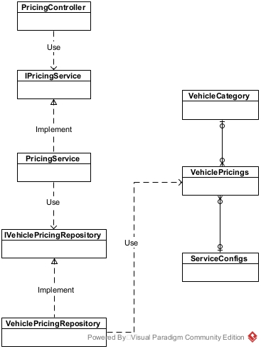

**3.1.2 Create Pricing Sequence Diagram**

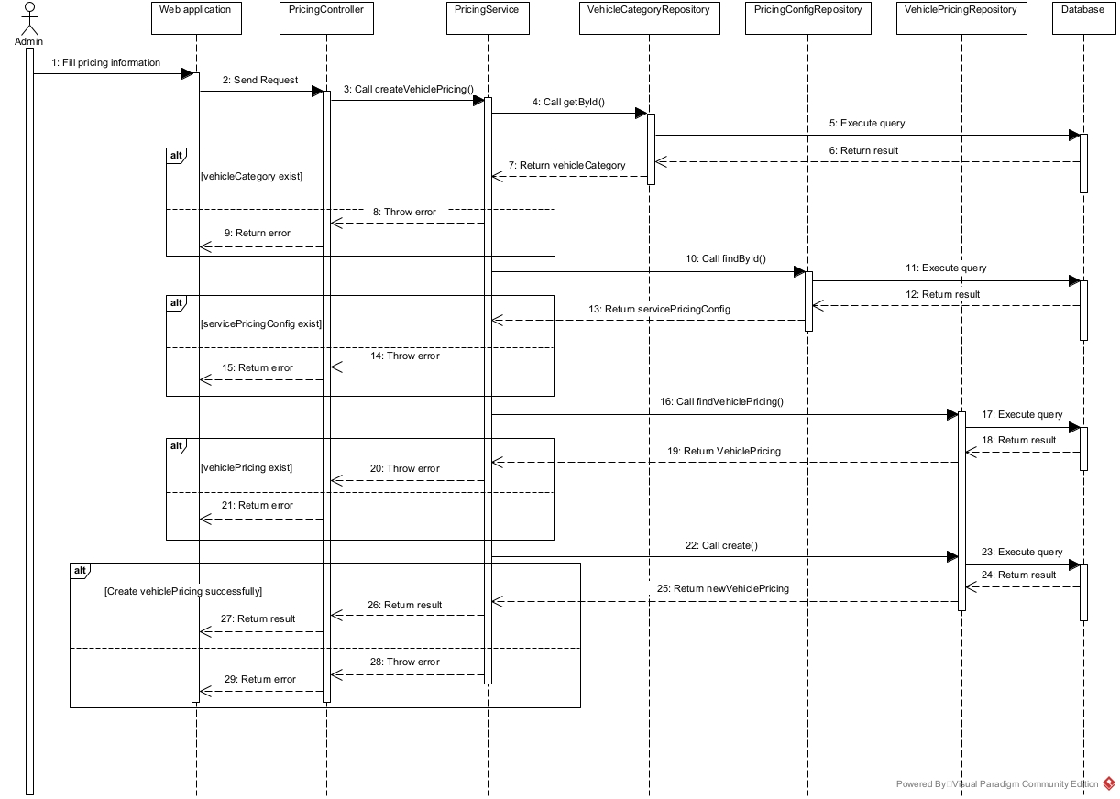

#### 3.1.3 Update Pricing Sequence Diagram

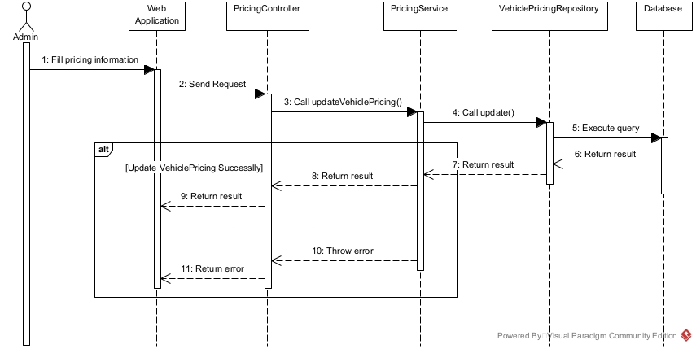

### 3.2 Manage Booking

#### 3.2.1 Booking Class Diagram

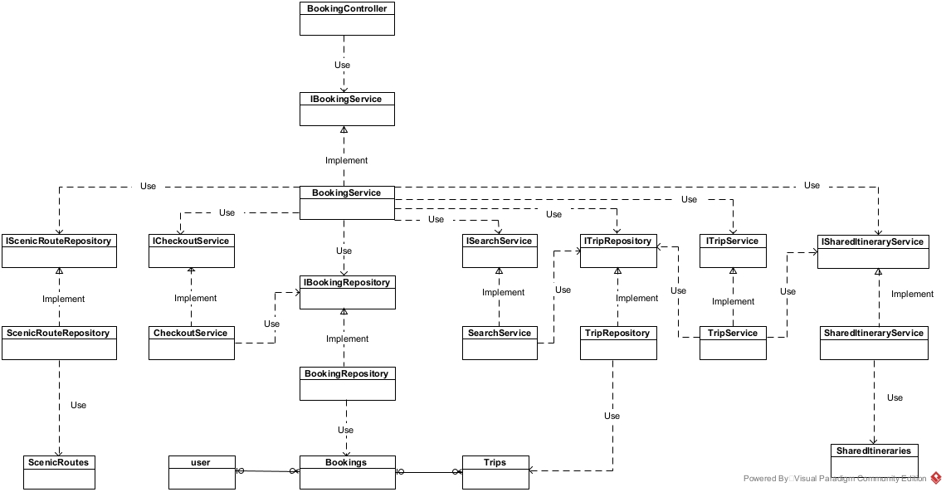

#### 3.2.2 Booking Activity Diagram

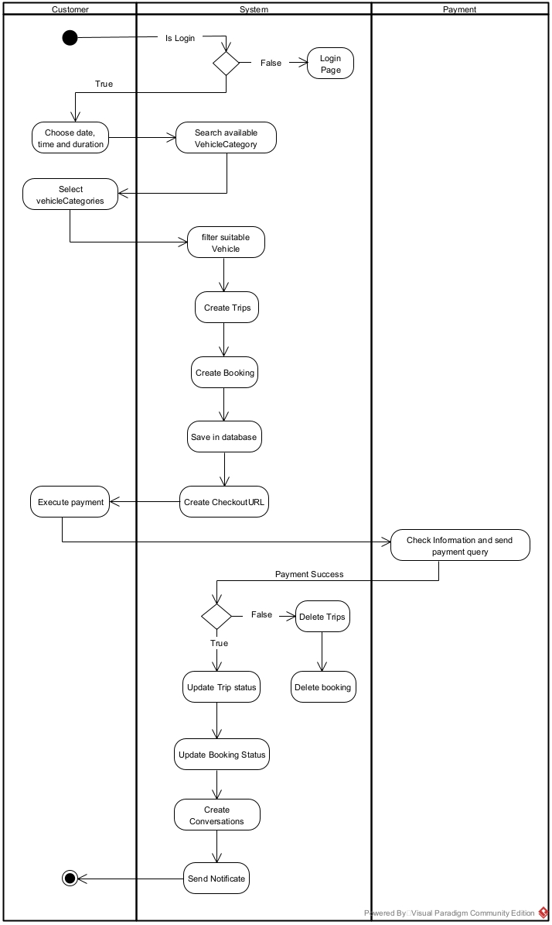 **3.2.3 Create BookingHour Sequence Diagram**

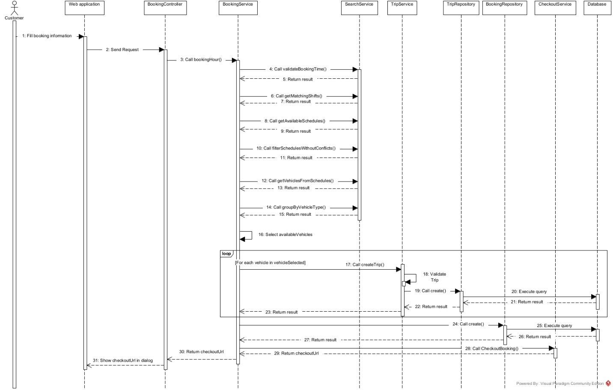

#### 3.2.3 Create BookingScenicRoute Sequence Diagram

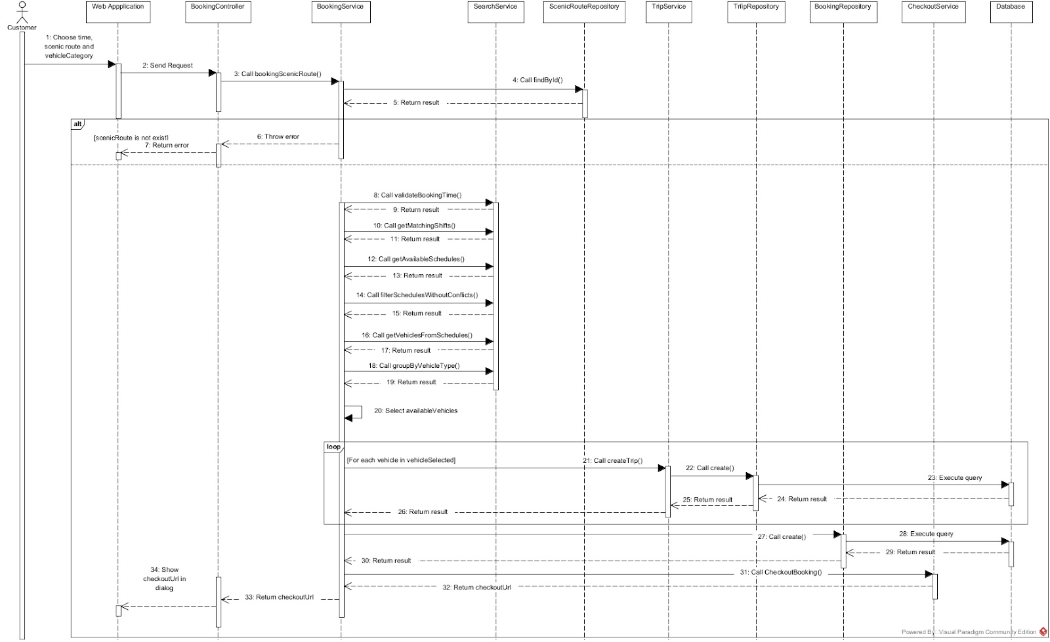

#### 3.2.4 Create BookingDestination Sequence Diagram

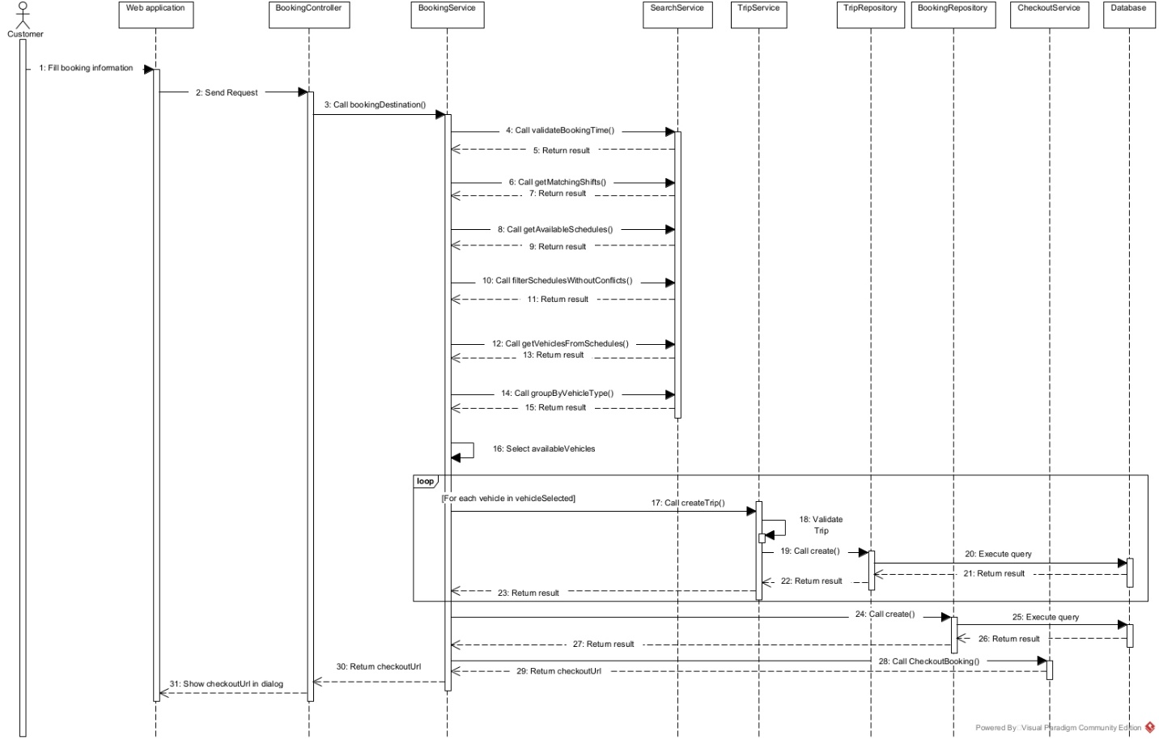

#### 3.2.5 Create BookingShared Sequence Diagram

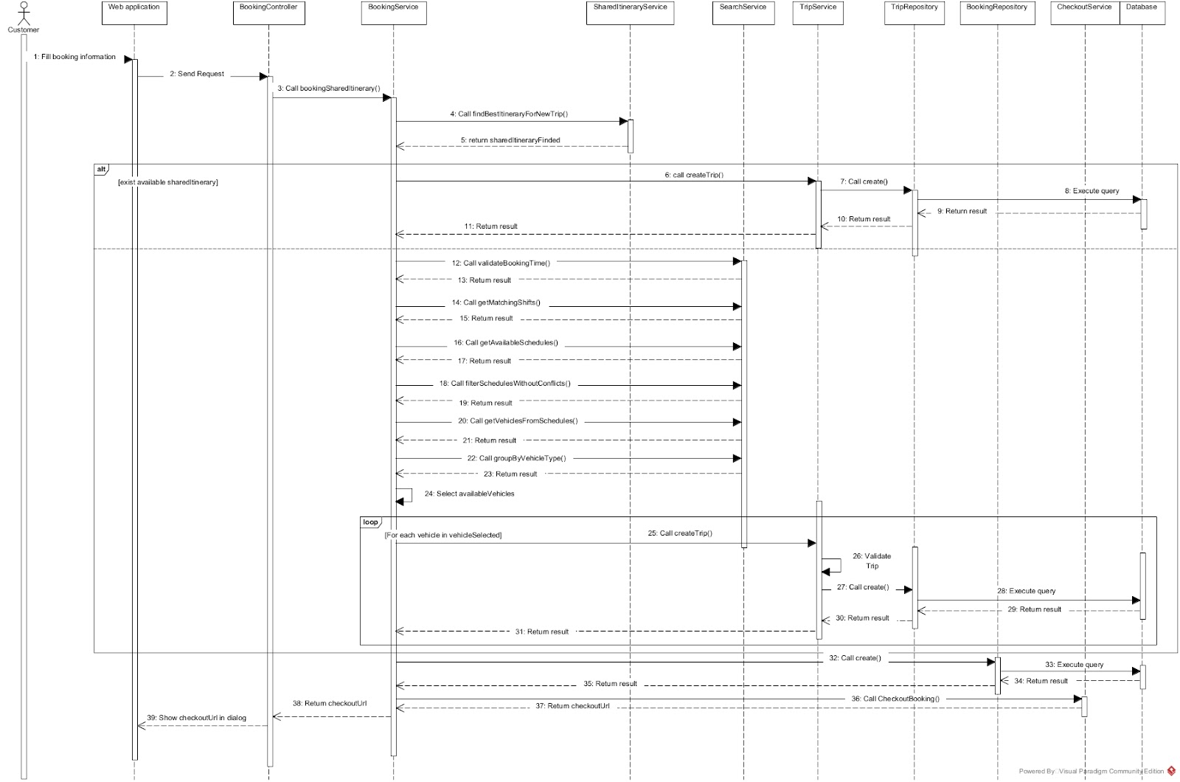

#### 3.2.6 Checkout Booking Sequence Diagram

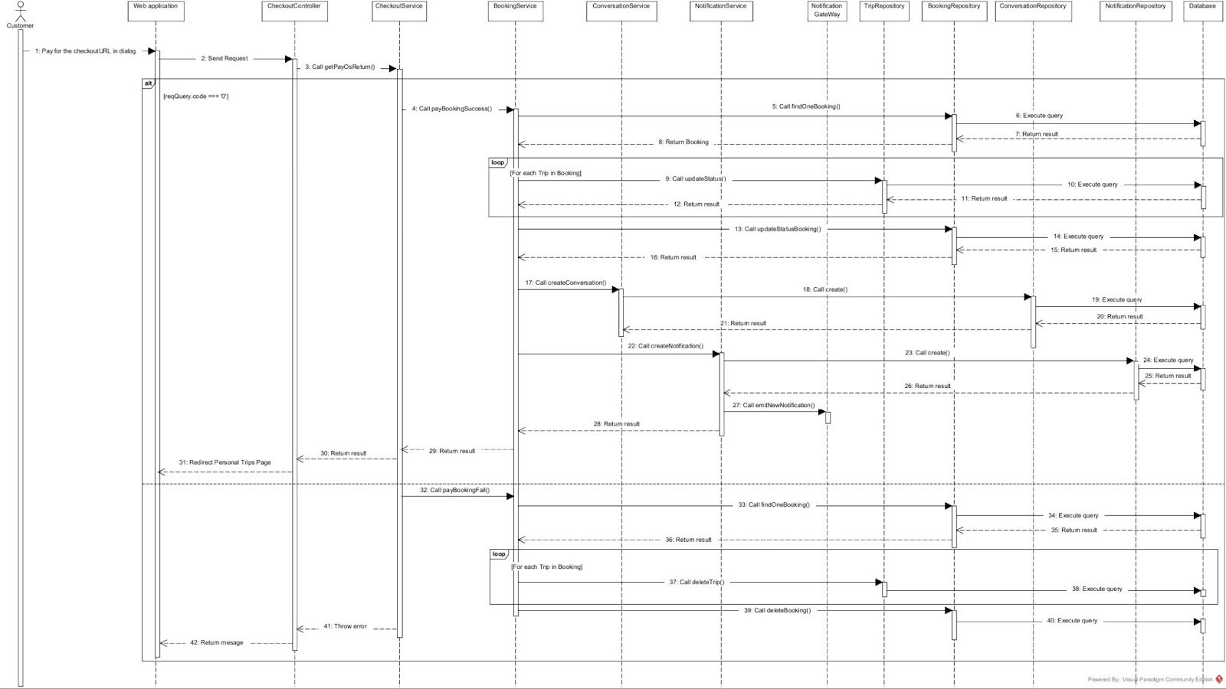

### 3.3 Manage Trip

#### 3.3.1 Trip Class Diagram

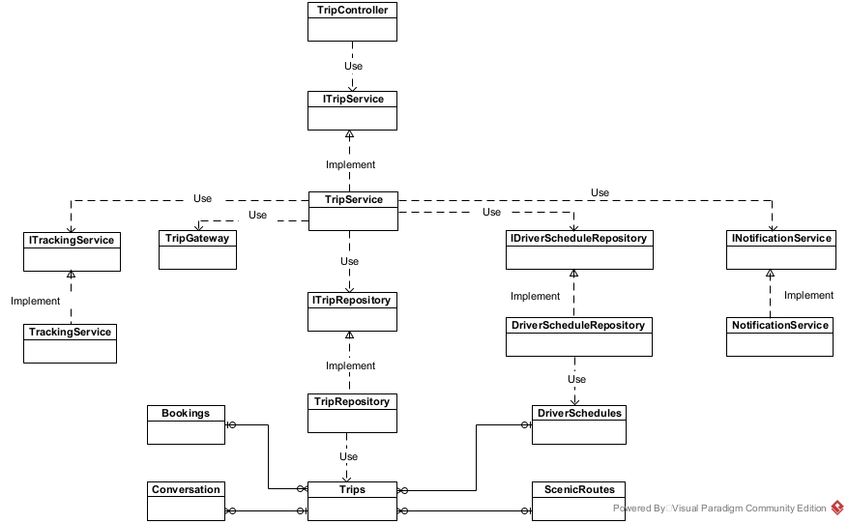

#### 3.3.2 Driver Execute Trip Activity Diagram

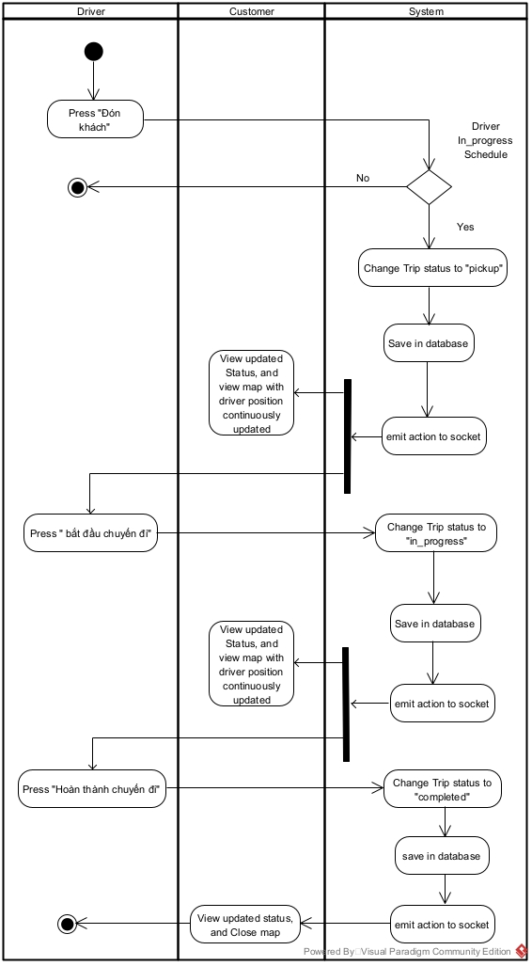

#### 3.3.2 Driver Pickup Trip Sequence Diagram

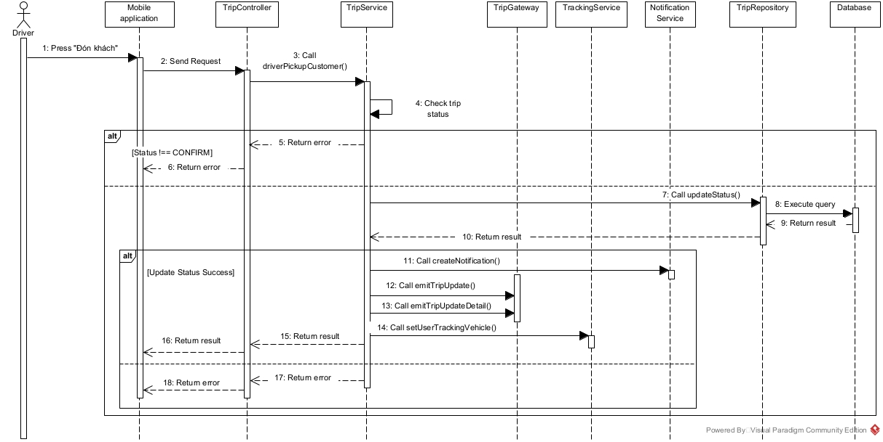

#### 3.3.3 Driver Start Trip Sequence Diagram

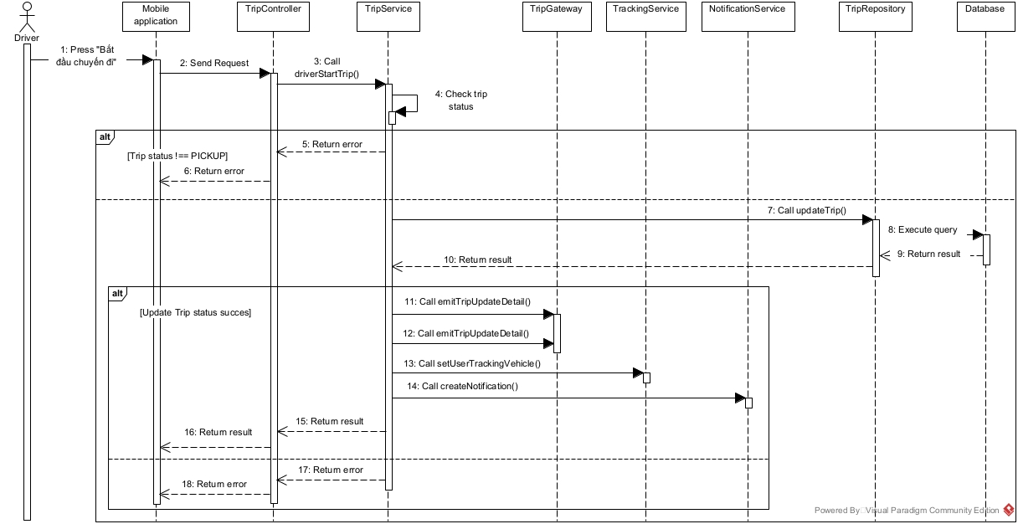

#### 3.3.4 Driver Complete Trip Sequence Diagram

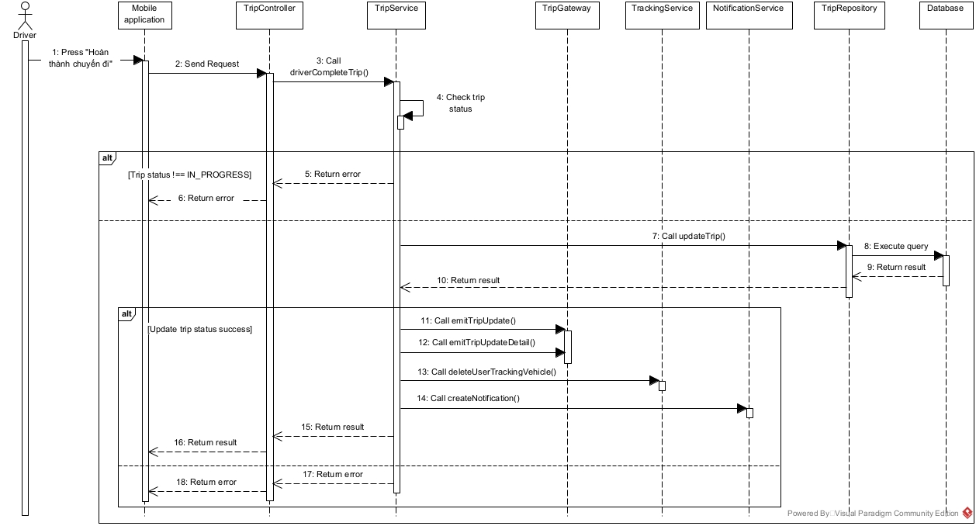

#### 3.3.5 Cancel Trip Sequence Diagram

#### 

#### 3.3.6 Tracking Vehicle Sequence Diagram

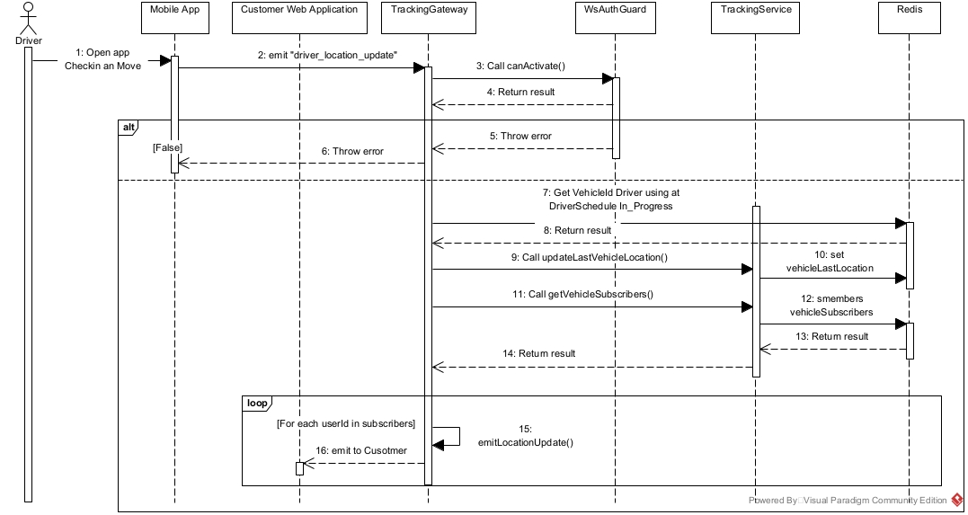

#### 3.3.5 Trip State Machine Diagram

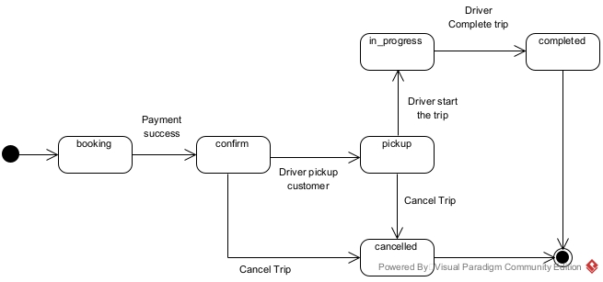

**3.4 Manage DriverSchedule**

**3.4.1 DriverSchedule Class Diagram**

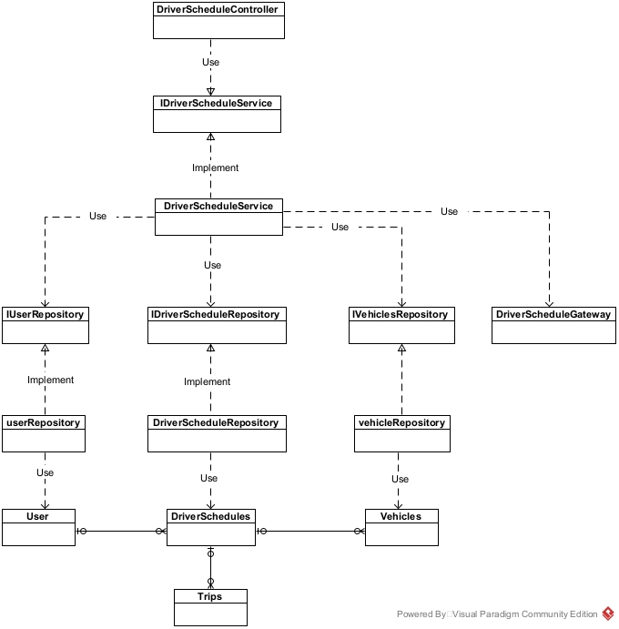

**3.4.2 Create DriverSchedule Sequence Diagram**

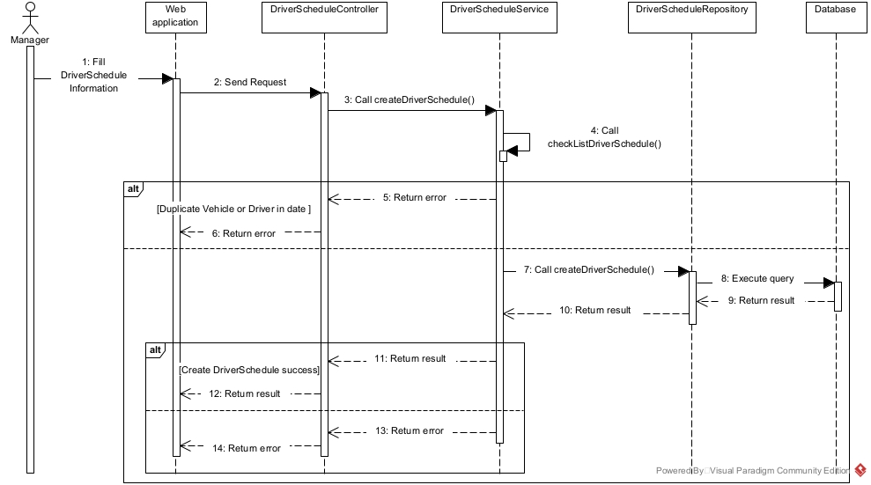

**3.4.3 Update DriverSchedule Sequence Diagram**

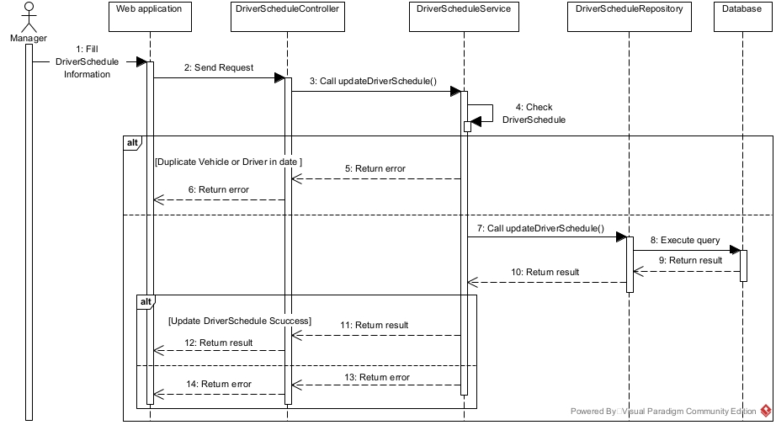

**3.4.5 Driver Checkin DriverSchedule Sequence Diagram**

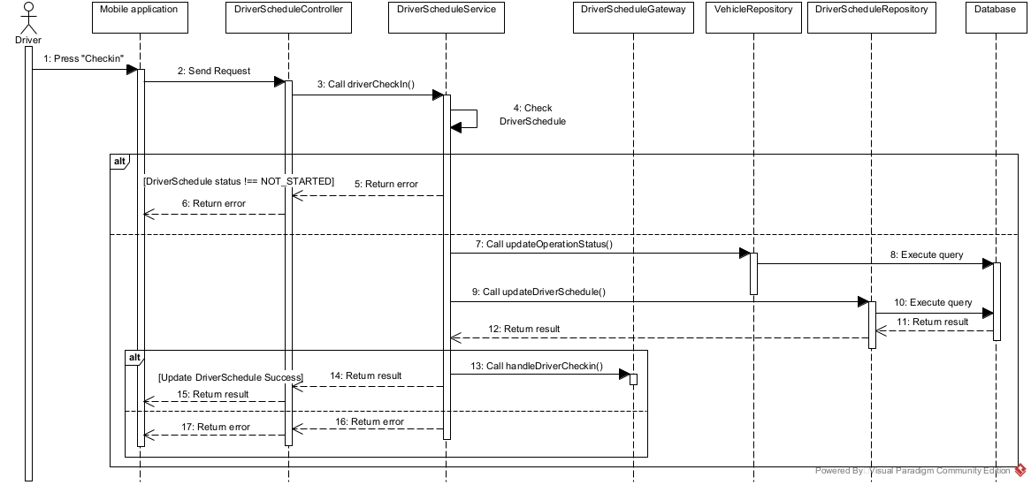

**3.4.6 Driver Checkout DriverSchedule Sequence Diagram**

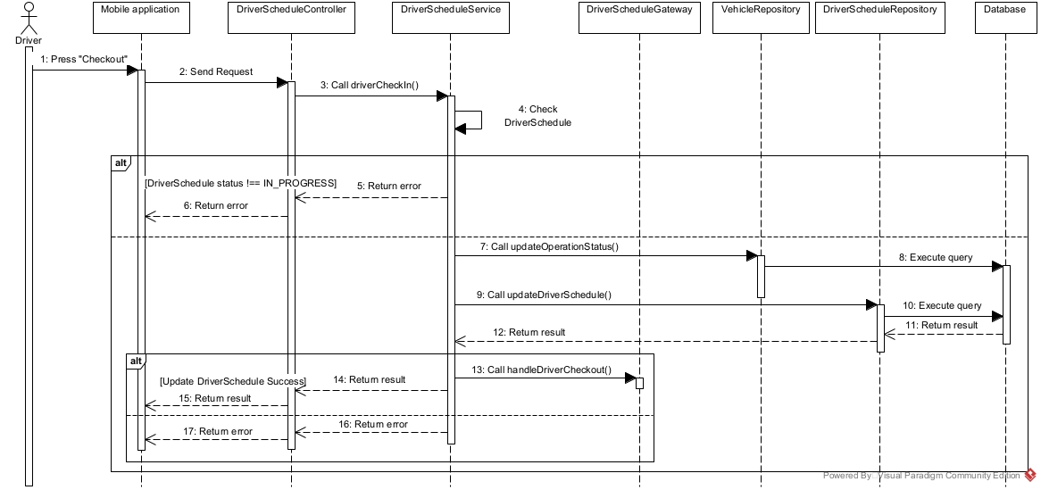

#### 3.4.7 DriverSchedule State Machine Diagram

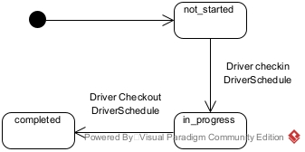

**3.5 Manage ScenicRoute**

#### 3.5.1 ScenicRoute Class Diagram

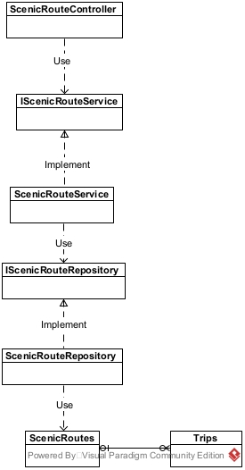

#### 3.5.2 Create ScenicRoute Sequence Diagram

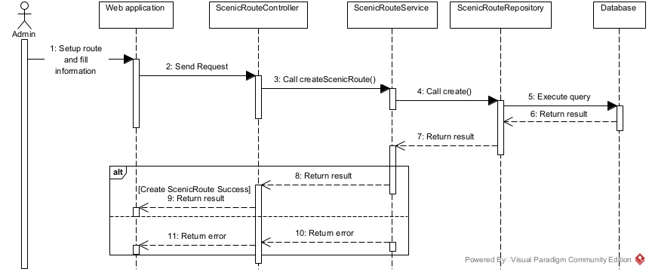

#### 3.5.3 Update ScenicRoute Sequence Diagram

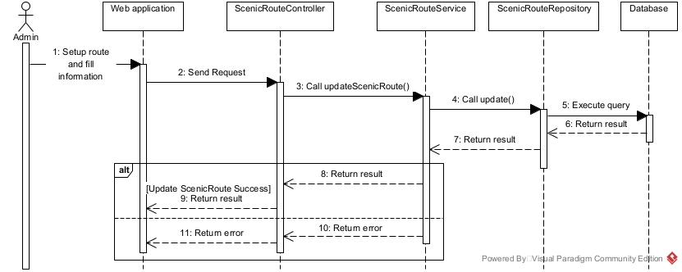

#### 3.5.4 ScenicRoute State Machine Diagram

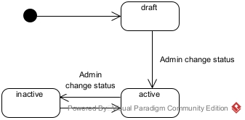

**3.6 Manage Vehicle**

#### 3.6.1 Vehicle Class Diagram

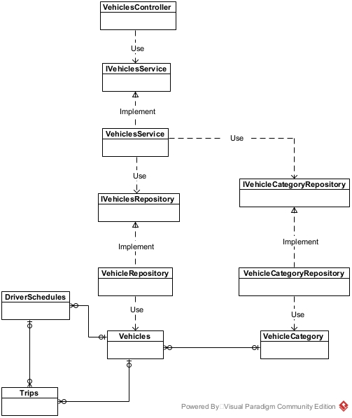

#### 3.6.2 Create Vehicle Sequence Diagram

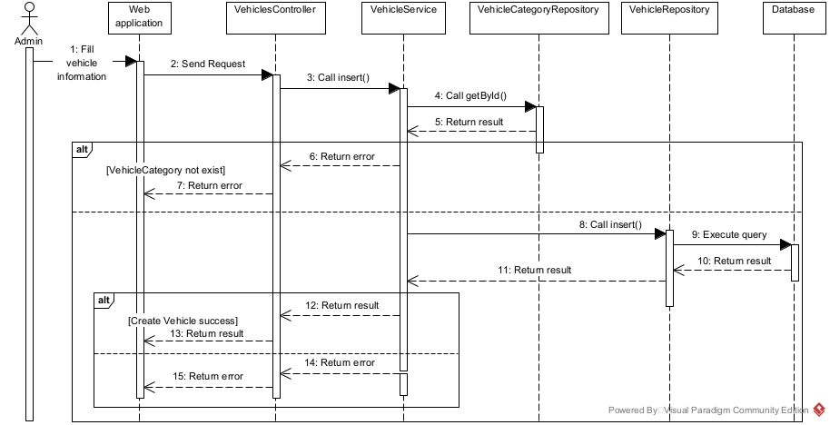

#### 3.6.2 Update Vehicle Sequence Diagram

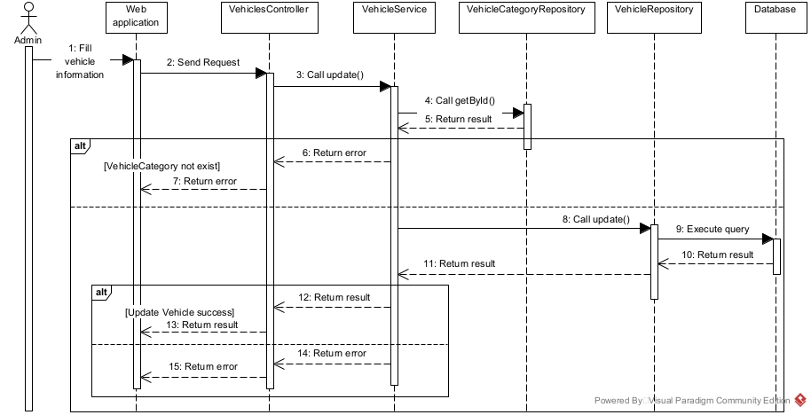

#### 3.6.3 VehicleCondition State Machine Diagram

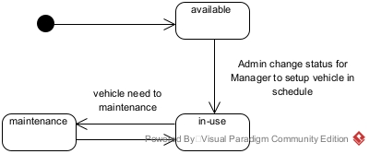

#### 3.6.4 VehicleOperationStatus State Machine Diagram

